CUSTOMER MEETING SUMMARY

- FORMULAS AND CALCULATIONS
  - Some minimal changes about the safety factor (now we know what it is and we have a sort of formula to calculate it)
  - The safety factor (CS: Coefficiente di Sicurezza) is the factor that tells you if the pylon is too stressed
    - We have a Cmin; each pyllon has its own CS for each combination of debris+traffic
    - The things are ok if CS > CSmin
    - We'll have to store the minimal CS for each pyllon related at one combination
    - Very difficult to understand in italian (for me), too much difficult to explain to you in english :-(
  - We have a maximum domain described by a third order equation (Lorenzo is trying to write it) related to the Csmin described by:
    - x axis: N → pressure
    - y axis: M → bending moment
  - Each pyllon will be described by:
    - M
    - N
    - combination Debris+Traffic (related to the CS)
    - worst CS
  - We have to show the pyllons

- LEVELS AND USERS → WEB SITE PAGES/GRAPHS
  - External User
    - current state view
      - wind speed graph (speed, max speed) → the max values are points
      - wind direction graph (direction, max direction) → the max values are points

      - water level and river bed height
      - pictures Mantova and Modena side
      - wind roses above google maps image of the bridge
      - the stack image (with also flow direction) → we'll provide you all the picture needed
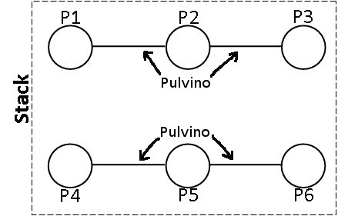

      - labels (values):
        - current flow rate value [(m^3)/s]
        - current wind speed [m/s]
        - current wind direction
        - current water level (above sea level) [m]
        - current river bed height (above sea level)[m]
        - current water speed [m/s]
      - on the footer, if possible, the last update of the data (timestamp like 22/11/2013 – 08:03:59 or something similar :-) ) → sorry Miraldi ;-)
    - cannot see (for the moment) the historical graphs → if we want to implement the historical graphs also for the external user is up to us, so for the moment I think we have to focus on current view
    - can logs in (if he has the right credentials ;-) )
  - Operator
    - has to logs in ;-) (obviously)
    - current state view:
      - the same things of the external user
      - the M-N domain (the domain of the CS)
      - each pylon in this domain (from the worst case table → Lorenzo is describing that in his document)
      - this table (you'll find the values in a table in the DB):
#pylon | Worst CS | Combination number/label | N | M | Tx | Ty | Mx | My
Pylon #1
Pylon #2
Pylon #3
Pylon #4
Pylon #5
Pylon #6
      - Checkbox in which he could check the options D/T
    - historical graphs/view:
      - he had to chose the time interval (from - to)
      - wind speed graph graph (speed, max speed) related to the time interval chosen
      - wind direction graph graph (direction, max direction) related to the time interval chosen
      - water level and river bed height graph related to the time interval chosen
      - CS trend (only the worst → thus the worst for the combination D=1, T=1)
        - x axis: time; y axis: a number > 1

    - default options for the time interval:
      - specific day (“I want to see the graph of the day: dd/mm/yyyy”)
      - last month (from the fist day of the month untill now)
      - specific month
      - specify a customized time interval (from dd/mm/yyyy to dd/mm/yyyy)

  - Engineer
    - can log in :-)
    - the same current state view of the operator
    - the same historical view (with the same options) of the operator
    - the parameters “file”
      - he can change the values of the parameters (all parameters)
      - then he can click “save”/“submit” → “are you sure????? → ok”
      - then the math engine has to re-do the calculation, re-fill the fields in the DB, etc to arrive to another new representations of the graphs (current state view)
  - Administrator
    - can log in
    - can add/remove/edit a user
    - cannot see values, graphs and so on
    - can see and modify the attributes of a user:
      - name
      - surname
      - e-mail
      - username
      - ….
      - ….
      - (except the password, obviously ;-) )

